Soil Mechanics in Vacuum Chamber
Downloaded from ascelibrary.org by University of Liverpool on 07/22/25. Copyright ASCE. For personal use only; all rights reserved.
G. H. Go¹; J. Lee²; H. S. Shin³; B. H. Rhu⁴; and H. W. Jin⁵
¹Future Strategy and Convergence Research Institute, Korea Institute of Civil Engineering and Building Technology, 283, Goyang-daero, Ilsanseo-gu, Goyang-si, Gyeonggi-do 10223. E-mail: gyuhyungo@kict.re.kr
²Future Strategy and Convergence Research Institute, Korea Institute of Civil Engineering and Building Technology, 283, Goyang-daero, Ilsanseo-gu, Goyang-si, Gyeonggi-do 10223. E-mail: jlee@kict.re.kr
³Future Strategy and Convergence Research Institute, Korea Institute of Civil Engineering and Building Technology, 283, Goyang-daero, Ilsanseo-gu, Goyang-si, Gyeonggi-do 10223. E-mail: hyushin@kict.re.kr
⁴Geotechnical Engineering Research Institute, Korea Institute of Civil Engineering and Building Technology, 283, Goyang-daero, Ilsanseo-gu, Goyang-si, Gyeonggi-do 10223. E-mail: tnt306@kict.re.kr
⁵Geospace Engineering Laboratory, Univ. of Science and Technology, 283, Goyang-daero, Ilsanseo-gu, Goyang-si, Gyeonggi-do 10223. E-mail: hunu1231@kict.re.kr

ABSTRACT
The dust vacuum chamber is an essential infrastructure for the verification of space exploration equipment, especially extraterrestrial missions for in situ resource utilization (ISRU). This study presents a new approach in soil mechanics that is particularly applicable to the dust vacuum chamber. One of the main issues in operating the dust vacuum chamber is soil disturbance problems during the evacuation. Thus, the appropriate vacuum rate was suggested to minimize the soil disturbance in the dust vacuum chamber using theoretical and numerical approaches. Firstly, the simple analytical solutions were used to provide approximate maximum discharge velocity and evacuation time to finish air flow through a soil specimen at a given vacuum pressure. Then, a two dimensional finite element model was developed which simulates the hydro-mechanical behavior of the soil specimen in a vacuum chamber with respect to different vacuum rates. From the numerical analysis results, optimum guidelines have been proposed to ensure that soil disturbance is minimized.

INTRODUCTION
Recently, the trend in space exploration has been shifting from a remote exploration using orbiters to a surface mission using rover and lander. The analysis results of “LCROSS impact mission” performed by NASA in 2009 showed a key indicator that water ice is present in the
floor of the crater (Colaprete et al. 2010). Since then, studies on the technology for lunar surface exploration are gradually being extended. Among them, developing and verifying the exploration equipment that will be mounted on the rover or lander are the most essential parts. For the verification of the equipment used in the lunar surface mission, thorough performance tests in dirty vacuum chamber (DVC) that simulates lunar surface conditions are required.
Thus, there have been several studies on the development and verification of equipment for surface exploration, based on experimental or theoretical approaches. For example, Zacny et al (2012) presented a method of deploying and anchoring the next generation Corner Cube Reflector system(LLRRA-21) to 50 cm depth, and tested a drill’s performance in compacted

JSC-1a lunar soil simulant and inside a 3.5m tall vacuum chamber. Also, Green and Zacny (2014) tested a percussive excavation system at Earth atmospheric pressure and at Martian atmospheric pressure to determine whether a change in atmospheric pressure affects excavation forces during percussive digging. In order to make Martian atmospheric condition, they evacuated the air until 600 Pa in the vacuum chamber filled with JSC-1A soil simulant. However, one of the main
issues in operating the dirty vacuum chamber is soil disturbance problems during the evacuation. The soil disturbance caused by the depressurization causes difficulties in maintaining the initial condition of the soil bin (Kleinhenz and Wilkinson 2014).
Thus, this study suggested a new operating guideline to minimize the soil disturbance in dust vacuum chamber. Simple theoretical solutions were calculated to provide approximate maximum discharge velocity at a given vacuum pressure. And then, finite element analyses were conducted to evaluate the hydro-mechanical behavior of the soil specimen with respect to different vacuum rates. Through this numerical approach, the optimum guideline was briefly proposed to ensure that the soil disturbance is minimized.

POROELASTICITY THEORY
During depletion of air pressure in the soil specimen, the stress is altered due to the change in pore air pressure. In this study, a “poroelasticity theory” proposed by Biot (1941) was applied to evaluate the hydro-mechanical behavior of soil specimen under depressurization conditions. The constitutive equation governing the poroelastic behavior relates to stress, strain, and pore air pressure:

σ = Cε −α_{B}ua I
where σ is the total stress, ε is the strain tensor, ua is the air pressure in the pore, αB is the Biot- Willis coefficient; it’s value is commonly considered as 1 for soft soils. The elastic matrix C is
(1)

expressed as a reciprocal of the coefficient of volume change (i.e., C=1/mv), Meanwhile, Eq. (1) defines a state of static equilibrium because the changes in the solid equilibrate quickly, and
hence there are no time-dependent terms. However, the time rate of change in strain ( ∂εvol ∂t )
appears as a coupling term in the following continuity flow equation since the solids equation becomes quasi-static when solved simultaneously with a time-dependent flow model.
Here, the continuity equation for flow in poroelastic media is defined as

ρ S ∂ua + ∇(u q ) = −ρ α

∂εvol
(2)

ª ∂t
a a a B ∂t

where ρa is the air density, and the storage S is expressed as
n

; n is the porosity and ua is the

absolute air pressure. The right hand side term of Eq. (2) describes the increasing pore volume according to the change in strain. Also, the air velocity qa is calculated by Darcy’s law presented in Eq. (3).
ua

q =− K ∂ua
(3)

Downloaded from ascelibrary.org by University of Liverpool on 07/22/25. Copyright ASCE. For personal use only; all rights reserved.
ª μ ∂y
where K is the intrinsic permeability, and μ is the dynamic viscosity.
Meanwhile, when the effective stress becomes zero due to a seepage stress, the soil disturbance starts to happen. Accordingly, the maximum air velocity limit can be considered as the moment when the seepage force exceeds the soil’s dead load.

j = Wd

ρ ⋅ g ⋅ qmax ⋅ h = ρ
a k d
⋅ g ⋅ h

k = ρa ⋅ g ⋅ K
μ
(4)

qmax
= K ⋅ ρ ⋅ g
μ d

where j is the seepage stress, and Wd is the dead load of the soil specimen.
Downloaded from ascelibrary.org by University of Liverpool on 07/22/25. Copyright ASCE. For personal use only; all rights reserved.

Table 1. Material properties used in finite element model.
Property | Name | Value | Unit | Note
Young’s Modulus | E | 10 | MPa | constant
Biot-Willis coefficient | αB | 1 |  | constant
Particle density | ρd | 2750 | kg/m³ | constant
Air density | ρa | (ωb ua ) / RT | kg/m³ | variable
Porosity | n | 0.418 |  | constant
Dynamic viscosity of air | μ | 1.814E-05 | Pa·s | constant
Storage | S | n ua | 1/Pa | variable
Poisson’s ratio | ν | 0.25 |  | constant
Intrinsic permeability K 2.55E-13 m² constant
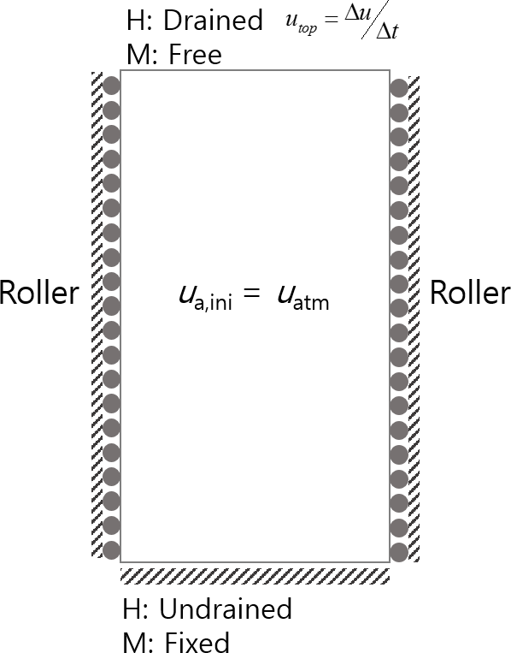
Figure 1. Boundary conditions of finite element model.

FINITE ELEMENT MODEL
Downloaded from ascelibrary.org by University of Liverpool on 07/22/25. Copyright ASCE. For personal use only; all rights reserved.
For the investigation of the poroelastic effects on the soil specimen during the depressurization, a two dimensional finite element model was set up which couples the behavior of fluid flow and geomechanics. The modeling area was set to a soil specimen with a depth of 0.047m, and the material properties of the specimen are as presented in Table 1. Initial pressure of the soil specimen was defined as atmospheric pressure. The depressurization proceeded at the top of the soil specimen and the other boundaries including bottom were defined as undrained. Although the intrinsic permeability was constant, the hydraulic conductivity acts as variable.
This is because the air density varies with pressure during the depressurization. For the solid mechanical part of the model, the top boundary was set to “free”, the bottom was defined as “fixed”. Also, both wall boundaries were defined as “rollers” which allows for y-direction movement (see Figure 1).

RESULTS AND DISCUSSION
Figure 2 shows the air velocity distribution at the middle point of the soil specimen when the vacuum rate was applied at -0.33 kPa/sec in the chamber. The air velocity was obtained from Eq.
(3). As the absolute pressure approaches the state of vacuum, the air velocity increases rapidly. This phenomenon results from the pressure gradient that goes up exponentially in the state of vacuum, and it induces a high drag force inside the soil specimen.

100
Absolute air pressure at middle point
Absolute air pressure (kPa)

80

60

40

20

0
0 50 100 150 200 250 300

0.00040
Air velocity at middle point

0.00035
Air velocity (m/s)

0.00030

0.00025

0.00020

0.00015

0.00010

0.00005

0.00000
0 50 100 150 200 250 300
Elapsed time (sec)

Figure 2. Air velocity and absolute pressure at the middle point of soil specimen according to a given vacuum rate.

Meanwhile, the soil disturbance phenomenon occurs when the effective stress becomes zero due to seepage stress. Based on a theoretical approach established in this study, the maximum air velocity(qmax) causing the soil disturbance was calculated. At given properties, the calculated qmax was about 0.000235 m/s. Theoretically, this means that the soil disturbance occurs 282.5 sec after the beginning of depressurization. At this moment, the vacuum pressure at the top of soil specimen was about -94 kPa since the vacuum rate was set to -0.33 kPa/sec. From the above results, it can be concluded that the vacuum rate should be reduced before the air flow reaches the maximum velocity limit.
Downloaded from ascelibrary.org by University of Liverpool on 07/22/25. Copyright ASCE. For personal use only; all rights reserved.
Figure 3 shows the air velocity distribution when the vacuum rate is controlled 10 seconds before the air velocity reaches the maximum velocity. Here, the vacuum rate was controlled from
-0.33 kPa/sec -0.11 kPa/sec. When the vacuum rate was decreased to -0.11 kPa/sec, the air velocity suddenly dropped and then it increased again. According to Kleinhenz's study (Kleinhenz et al. 2014), no disruptions are observed at pressures below 2.5 Torr, regardless of the pump rate. It implies that vacuum rate needs to be controlled adequately to maintain the initial condition of soil specimen until the vacuum pressure reaches a maximum allowable value (2.5 Torr). Ultimately, it is worth noting that this numerical approach can be used to suggest an optimal guideline for vacuum pump operation. The guidelines may include adequate vacuum rates for various soil scales and various kinds of soil properties.

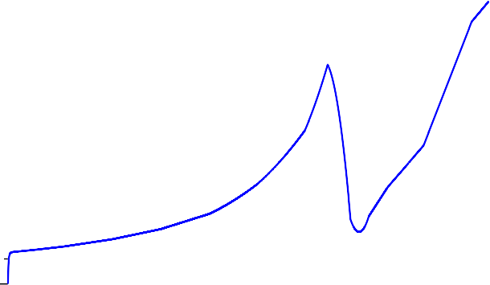
0.00035

0.00030

0.00025
Air velocity (m/s)

0.00020

0.00015

0.00010

0.00005

0.00000
0 50 100 150 200 250 300 350 400
Elapsed time (sec)
Figure 3. Air velocity distribution with controlled vacuum rate.

SUMMARY AND CONCLUSION
This study presented a new approach in soil mechanics that is particularly applicable to the dust vacuum chamber. One of the top issues in operating the dust vacuum chamber is soil disturbance problems during the evacuation. In order to investigate this phenomenon, the finite element model was used to simulate the hydro-mechanical behavior of the soil specimen in a vacuum chamber with respect to different vacuum rates. Using this numerical approach, the optimum guideline can be proposed to ensure that the soil disturbance is minimized. The main conclusions drawn from the study results are summarized as follows.

- New theoretical approach provided the insight of the hydro-mechanical behavior of the soil in DVC during depressurization process.
Downloaded from ascelibrary.org by University of Liverpool on 07/22/25. Copyright ASCE. For personal use only; all rights reserved.
- The finite element model used in this study can be used to provide an appropriate vacuum rate during depressurization.
- These imply that the new theoretical approach is applicable for the optimum DVC operation that can minimize soil disturbance.
- During the depressurization, the vacuum rate should be controlled adequately to maintain the initial condition of soil specimen until the vacuum pressure reaches a maximum allowable value.

ACKNOWLEDGEMENTS
This research was supported by the research project “Development of environmental simulator and advanced construction technologies over TRL6 in extreme conditions" funded by Korea Institute of Civil Engineering and Building Technology (KICT).

REFERENCES
Colaprete, A. et al., (2010). “Detection of water in the LCROSS ejecta plume.” Science,
330(6003), 463–468.
Biot, M.A. (1941). "General theory of three dimensional consolidation." J. Appl. Phys., 12, 155– 164.
Green, A., Zacny, K. (2014). “Effect of Mars atmospheric pressure on percussive excavation forces.” J. Terramech., 51, 43-52.
Kleinhenz, J.E. and Wilkinson, R.A. (2014). “Development and testing of an ISRU soil mechanics vacuum test facility.” NASA/TM-2014-218389, National Aeronautics and Space Administration, Washington, D.C.
Zacny, K., Currie D., Paulsen G., Szwarc T., Chu P. (2012). “Development and testing of the pneumatic lunar drill for the Emplacement of the corner cube reflector on the Moon.” Planet. Space Sci., 71, 131-141.

